**App Flow Redesign Case Study: myStop Mobile**

**Intro**: myStop Mobile is an application that provides users with real-time bus status and trip planning features. It is currently used in over 50 cities to detail bus transit information based on the user’s location.

Although myStop Mobile has tens of thousands of users across the country, the usability and user experience are not up to par for an application of this scale. In particular, the list of stops has no organization and makes it difficult for users to plan their routes.

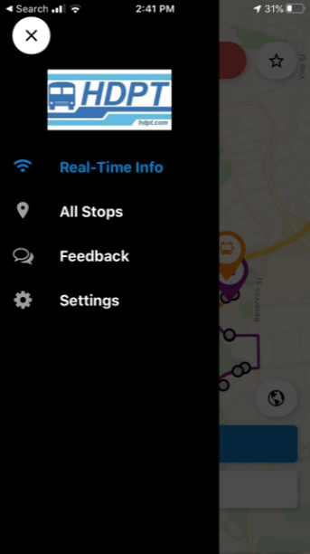 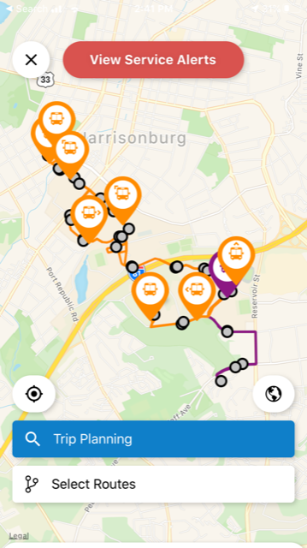 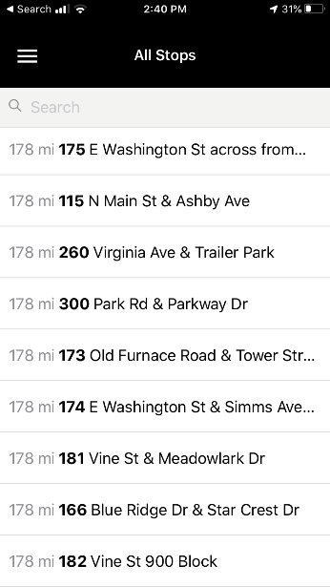

Current app flow

**Primary users**: The primary users of this application are individuals that rely on public transportation to get from one place to another. They range in age from youth to adults.

**Research**:

As a user of this app, I have experienced firsthand how poor the usability is and how frustrating this can be. Due to this, I conducted a case study in which I surveyed myStop users to collect their thoughts on the app.

**Design question**: “How might we improve the experience of individuals who utilize the myStop app to plan their bus routes?”

To gain insight on the individuals whom I was researching, I asked questions relating to their app use and favorite features.

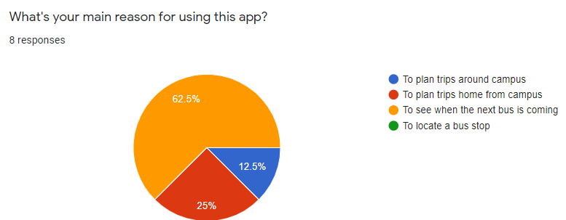

More than half the individuals surveyed stated their main reason for using the app is to see when the next bus is coming.

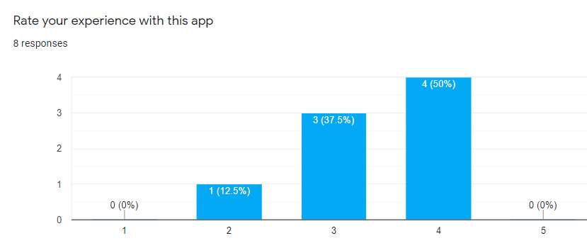

None of the responses for overall app experience were 5-stars which indicates the room for improvement.

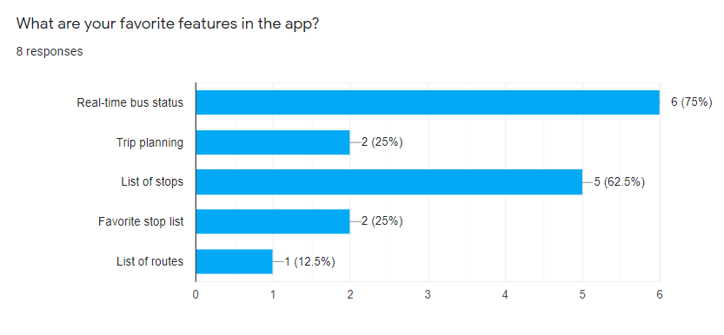

Most expressed that their favorite app features are the real-time bus status followed by the list of stops. This got me thinking as to how I could improve the user experience for these two features.

**Pain points**:

The most prominent issue with this mobile application is the usability. Navigating around the app and finding what you are looking for is frustrating and time consuming due to a lack of organization.

“This app is very hard to navigate and it isn’t very clear. As a freshman this made it hard to even use the app.”

“Sometimes it's hard to find specific stops because the locations aren't broken into categories.”

**Solution**:

Create a section for next available bus based on location and create categories to organize the stops.

**Wireframes:**

**Mockups:**

